**Project Design Phase-II**

**Data Flow Diagram & User Stories**

|  |  |
| --- | --- |
| Date | 25 June 2025 |
| Team ID | LTVIP2025TMID47510 |
| Project Name | Visualizing Housing Market Trends: An Analysis of Sale Prices and Features |
| Maximum Marks | 4 Marks |

**Data Flow Diagrams:**

A Data Flow Diagram (DFD) is a traditional visual representation of the information flows within a system. A neat and clear DFD can depict the right amount of the system requirement graphically. It shows how data enters and leaves the system, what changes the information, and where data is stored.



**Example:** [**(Simplified)**](https://developer.ibm.com/patterns/visualize-unstructured-text/)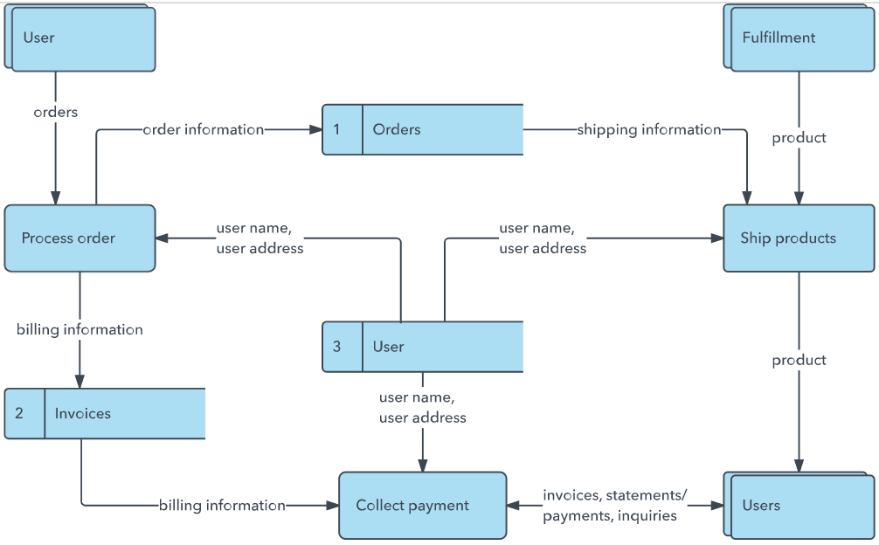

**User Stories**

Use the below template to list all the user stories for the product.

|  |  |  |  |  |  |  |
| --- | --- | --- | --- | --- | --- | --- |
| **User Type** | **Functional Requirement (Epic)** | **User Story No.** | **User Story / Task** | **Acceptance Criteria** | **Priority** | **Release** |
| **Customer (Mobile user)** | **User Registration** | USN-1 | As a user, I can register by providing email, password, and confirming password. | Registration is successful only with matching passwords and valid email format. Dashboard is accessible. | High | Sprint-1 |
|  |  | USN-2 | As a user, I receive a confirmation email after registration. | Confirmation email with verification link is received. Account activates only after confirmation. | High | Sprint-1 |
|  |  | USN-3 | As a user, I can register using Facebook login. | Facebook credentials allow successful login and redirection to dashboard. | Low | Sprint-2 |
|  |  | USN-4 | As a user, I can register using Gmail login. | OAuth with Gmail succeeds and user is logged in instantly. | Medium | Sprint-1 |
| **Customer (Mobile user)** | **Login** | USN-5 | As a user, I can log in using my registered email and password. | System allows access only with valid credentials. Error message for invalid inputs. | High | Sprint-1 |
|  | **Dashboard Access** | USN-6 | As a user, I can view visualizations on the dashboard. | Dashboard shows graphs, KPIs, and alerts on air quality with proper rendering. | High | Sprint-2 |
|  | **Data Filtering** | USN-7 | As a user, I can apply filters (location, time, AQ level) on the dashboard. | Charts and tables respond instantly to applied filters. | Medium | Sprint-2 |
| **Customer (Web user)** | **Web Dashboard** | USN-8 | As a user, I can log in on the website and access all dashboard features. | Same experience as mobile app – responsive charts and filters. | High | Sprint-2 |
| **Customer Care Executive** | **User Analytics** | USN-9 | As an executive, I can view user engagement statistics and dashboard access history. | Admin panel shows user access logs and usage patterns. | Medium | Sprint-3 |
|  | **Query Resolution Panel** | USN-10 | As an executive, I can view and respond to customer queries from the app. | Queries are visible in queue and marked resolved after reply. | Medium | Sprint-3 |
| **Administrator** | **Dataset Management** | USN-11 | As an admin, I can upload, refresh, or delete air quality datasets. | Data is correctly uploaded and visualized after refresh. | High | Sprint-2 |
|  | **Role and Access Control** | USN-12 | As an admin, I can manage roles and control access (User/Executive/Admin). | Changes in roles reflect immediately in access permissions. | Medium | Sprint-3 |